**Step-by-Step Guide to Setting Up Your Developer Environment**

**1. Select Your Operating System (OS)**

**Download and Install Windows 11**

1. Visit the [Windows 11 download page](https://www.microsoft.com/software-download/windows11).
2. Click on "Download now" to get the Windows 11 Installation Assistant.
3. Follow the instructions provided by the Installation Assistant to upgrade your current OS to Windows 11.

**2. Install a Text Editor or Integrated Development Environment (IDE)**

**Download and Install Visual Studio Code (VS Code)**

1. Go to the [Visual Studio Code download page](https://code.visualstudio.com/Download).
2. Select the appropriate version for Windows and download it.
3. Run the installer and follow the setup wizard to install VS Code.

**3. Set Up Version Control System**

**Install Git**

1. Download Git for Windows from the [Git website](https://git-scm.com/download/win).
2. Run the installer and follow the setup instructions, leaving default settings as they are.
3. Open Git Bash (installed with Git) to configure Git with your user information:
4. 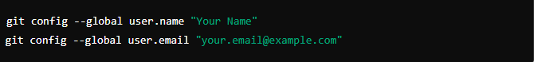

**Create a GitHub Account**

1. Visit the [GitHub website](https://github.com).
2. Click on "Sign up" and follow the instructions to create a new GitHub account.

**Initialize a Git Repository**

1. Open VS Code and create a new folder for your project.
2. Open the terminal in VS Code (Ctrl+`` or View > Terminal`).
3. Initialize a new Git repository:



1. Create a new file named README.md and add some initial content.
2. Stage and commit your changes:

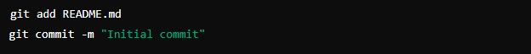

**Push to GitHub**

1. Create a new repository on GitHub.
2. Follow the instructions provided by GitHub to link your local repository to the GitHub repository and push your changes:

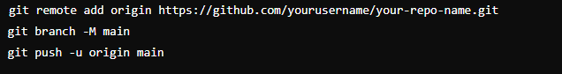

**4. Install Necessary Programming Languages and Runtimes**

**Install Python**

1. Download Python from the [official website](http://www.python.org).
2. Run the installer and make sure to check the box "Add Python to PATH".
3. Verify the installation by running the following command in the terminal:



**5. Install Package Managers**

**Install pip (Python's Package Manager)**

1. Pip is installed by default with Python. You can verify the installation by running:



**6. Configure a Database (MySQL)**

**Download and Install MySQL**

1. Visit the [MySQL download page](https://dev.mysql.com/downloads/windows/installer/5.7.html).
2. Download the MySQL Installer.
3. Run the installer and follow the setup instructions, choosing the "Developer Default" setup type.
4. Configure your MySQL server as per the setup wizard instructions.

**7. Set Up Development Environments and Virtualization (Optional)**

**Install Docker (Optional)**

1. Visit the Docker Desktop download page.
2. Download and install Docker Desktop for Windows.
3. Follow the installation instructions and verify by running:



**8. Explore Extensions and Plugins**

**Install Extensions for VS Code**

1. Open VS Code and go to the Extensions view by clicking on the Extensions icon in the Activity Bar on the side of the window.
2. Install useful extensions such as:
   * Python (for Python development)
   * GitLens (for enhanced Git capabilities)
   * Prettier (for code formatting)
   * Docker (if using Docker)